## 

**Hibernate Installation Guide**

Teaching Team:

* Riaz Ali
* Shikha Gupta
* Farzan Ahmad
* Emmanuel Imhontu

## 

## **Technologies and tools used**

* Java SE Development Kit 8
* IDE - Eclipse
* Hibernate 5.3.7.Final
* Maven 3.5.3
* MySQL - 8.0.19
* Mysql-connector-java-8.0.19.jar
* mysql-workbench-community-8.0.19-macos-x86_64.dmg

Let's start developing step by step Hibernate applications using Maven as project management and build tools.

## 

## 

## 

## 

## **Install Software**

1. Java SE Development Kit 8 <https://www.oracle.com/java/technologies/javase-jdk8-downloads.html>

2. IDE - Eclipse <https://www.eclipse.org/downloads/packages/release/luna/sr1/eclipse-ide-java-developers>

3. Hibernate 5.3.7.Final <https://hibernate.org/orm/releases/5.3/>

Choose 5.3.7.Final

4. Maven 3.5.3

<https://maven.apache.org/download.cgi>

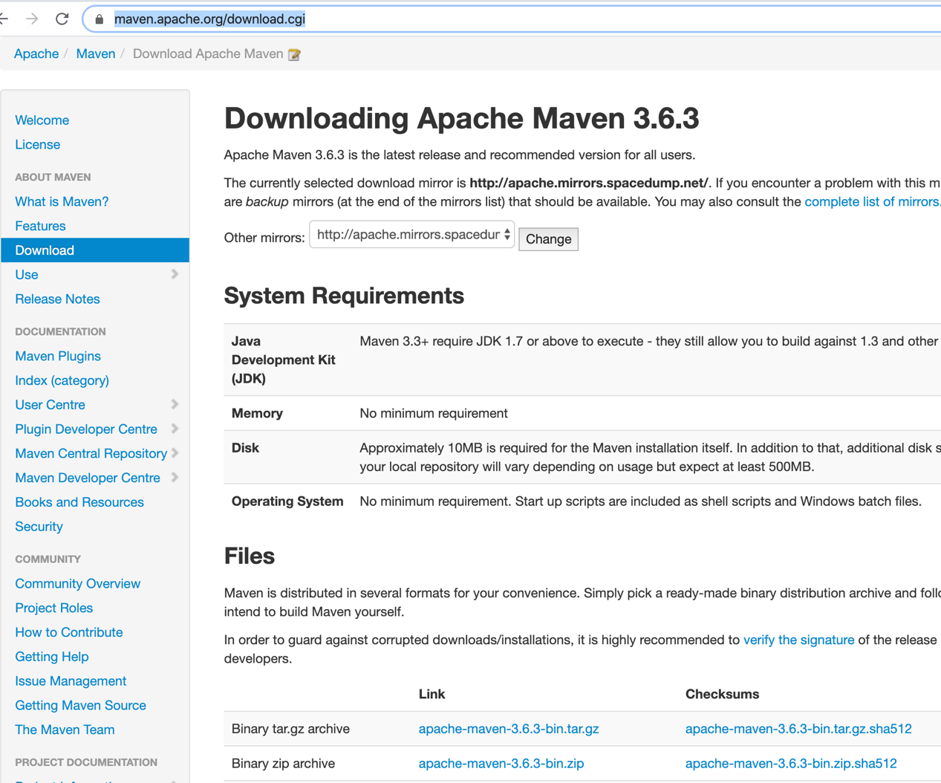

## Here choose files-link-apache-maven-3.6.3-bin.tar.gz

1. **MySQL - 8.0.19 & mysql-workbench-community-8.0.19-macos-x86_64.dmg**

* Install SQL .. Select **macOS 10.15 (x86, 64-bit), DMG Archive -ok**
* Double click on installed packege**-mysql-8.0.19-macos10.15-x86_64.pkg**
* **After finishing the installation part ,Go to Terminal and perform following step**

1. add MySQL to $PATH variable:

cd to your home folder

$ open -t .bash_profile

**NOTE**-If in ur system does not have .bash.profile .then don’t worry

Using Touch command create that file and paste that path

Try adding the following line to your .bash_profile file.

**export PATH=${PATH}:/usr/local/mysql/bin/**

1. Setting the MySQL root user password on OS X

$ mysql -u root -p

mysql$ ALTER USER 'root'@'localhost' IDENTIFIED BY 'MyNewPass';

* For check SQL installed or not and running status

Go to **System Preferences(find left corner of ur laptop screen -go to apple icon and choose System preferences)**

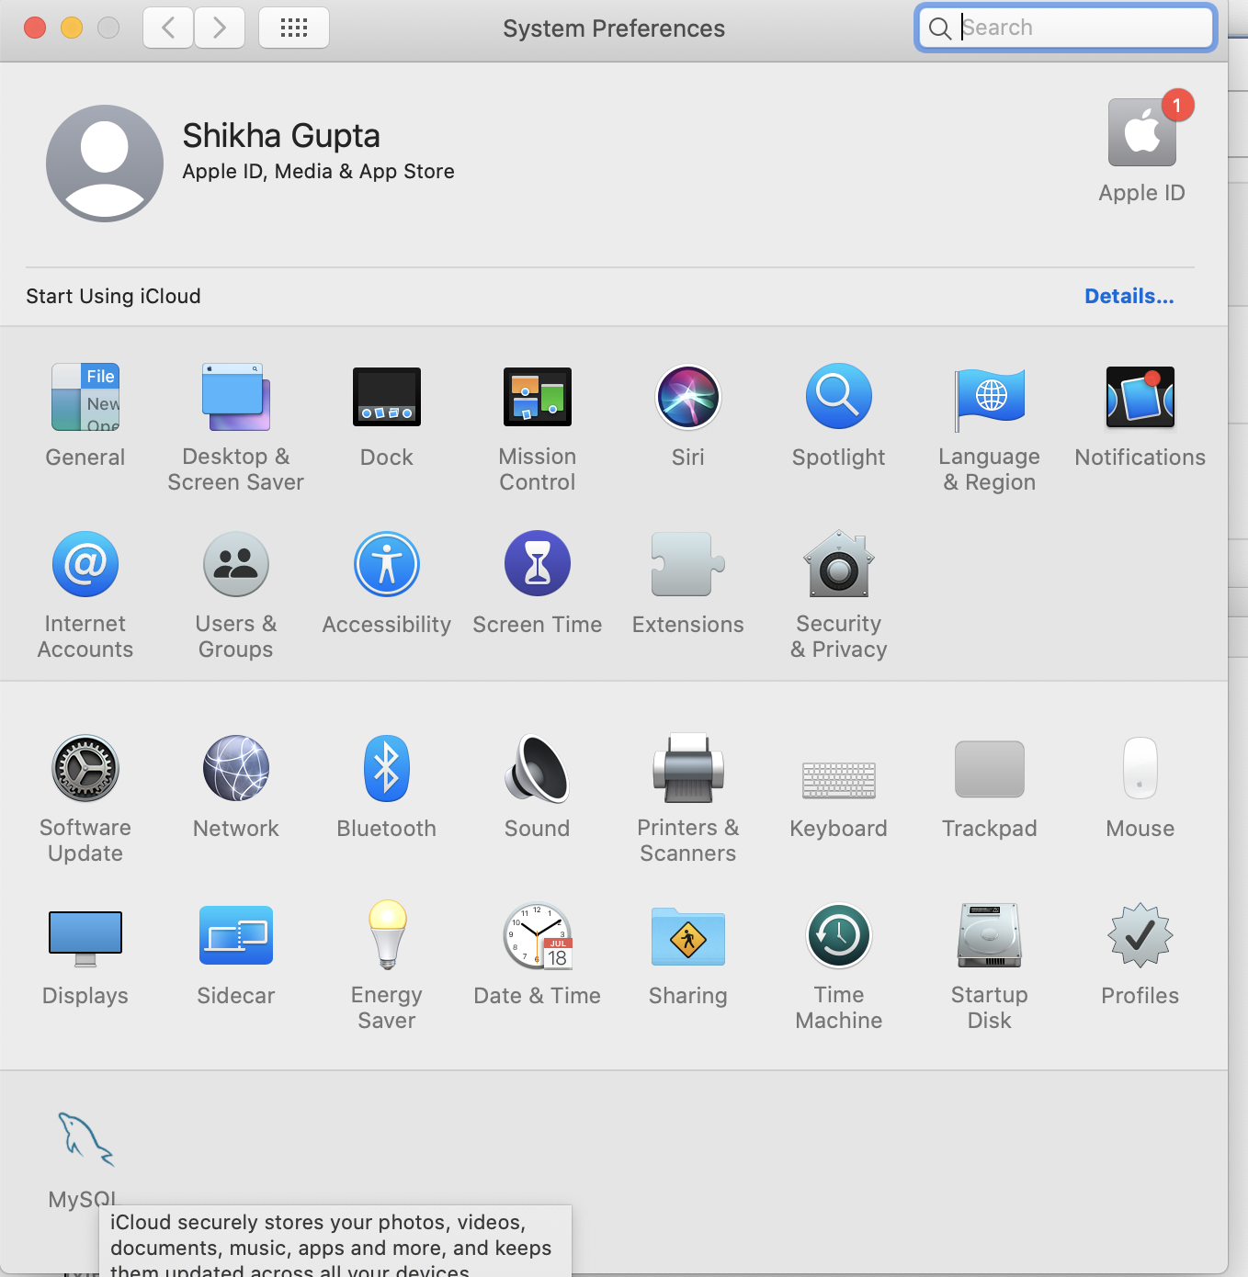

* **Go to MySQL,here u can check the status ..its running or not**

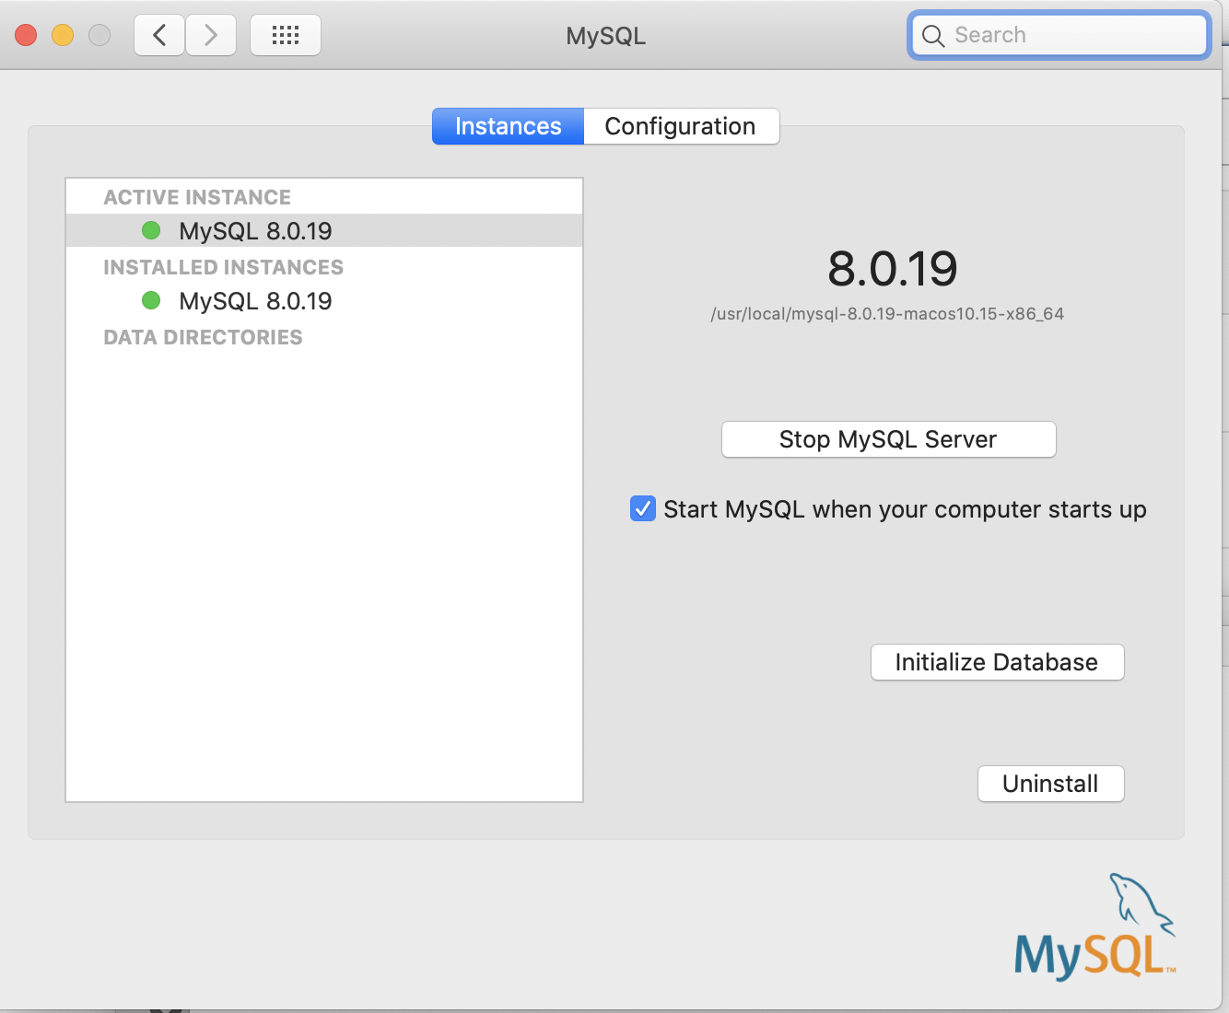

* **After that Go to Terminal-**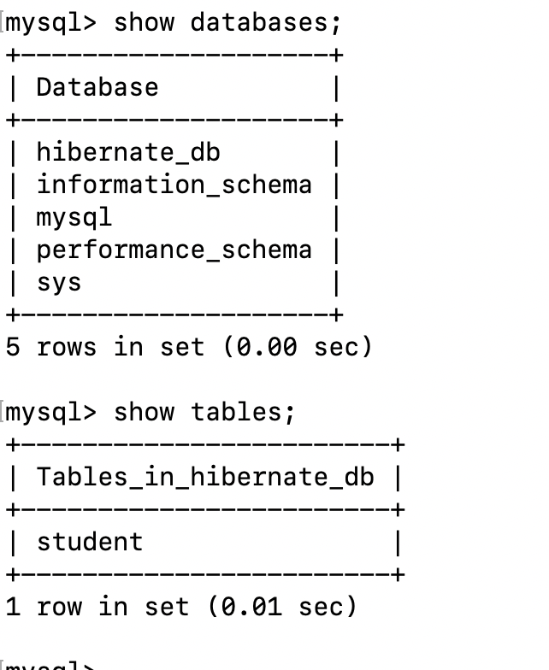

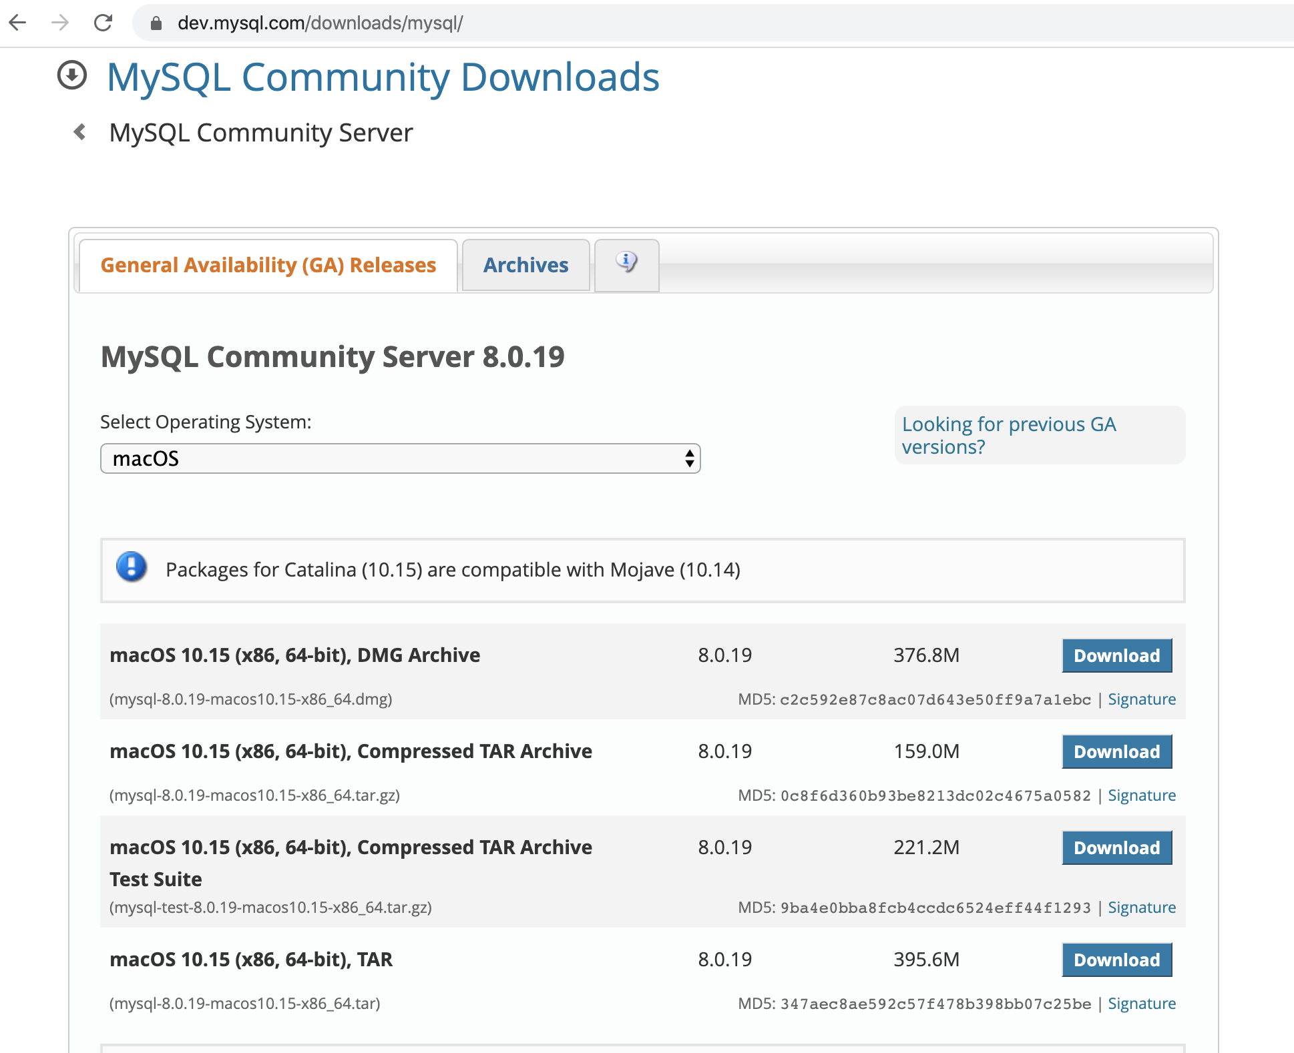

For SQLWorkbench -**macOS (x86, 64-bit), DMG Archive-Download**

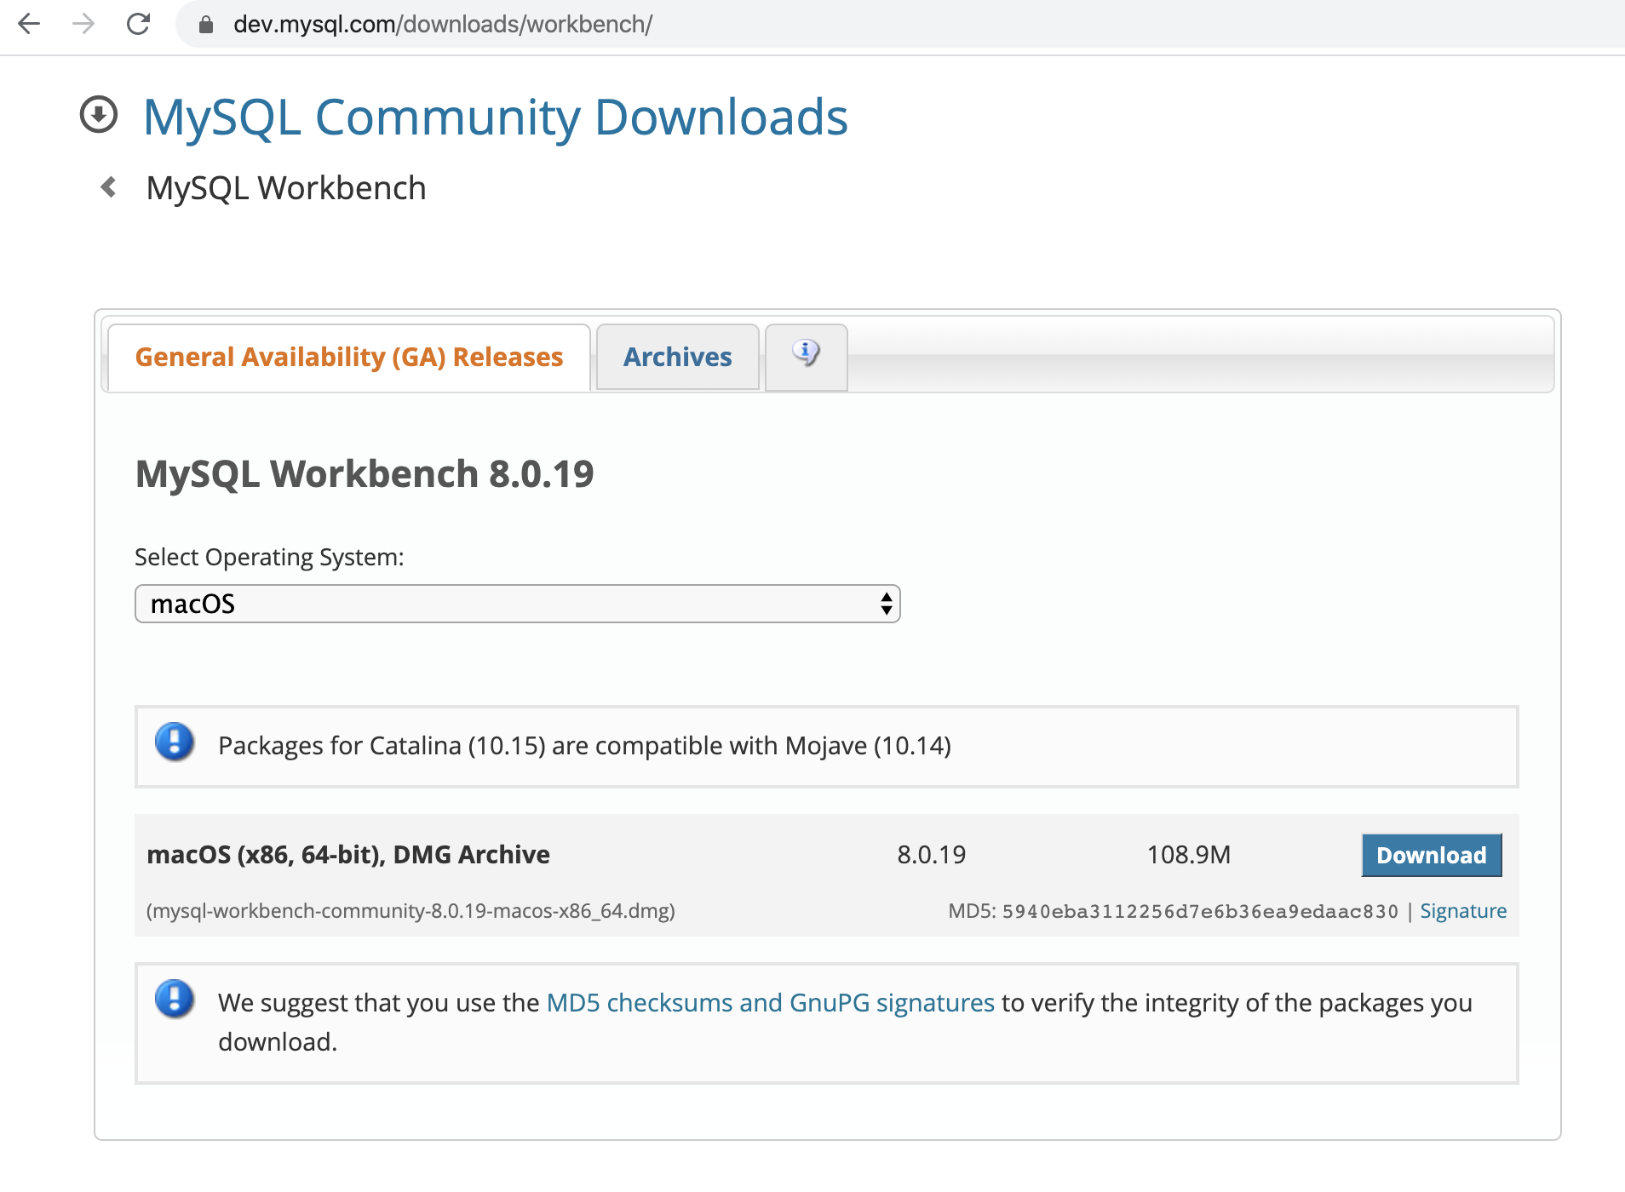

* After install the MySQL Workbench...Open it
* Create a New Schema-

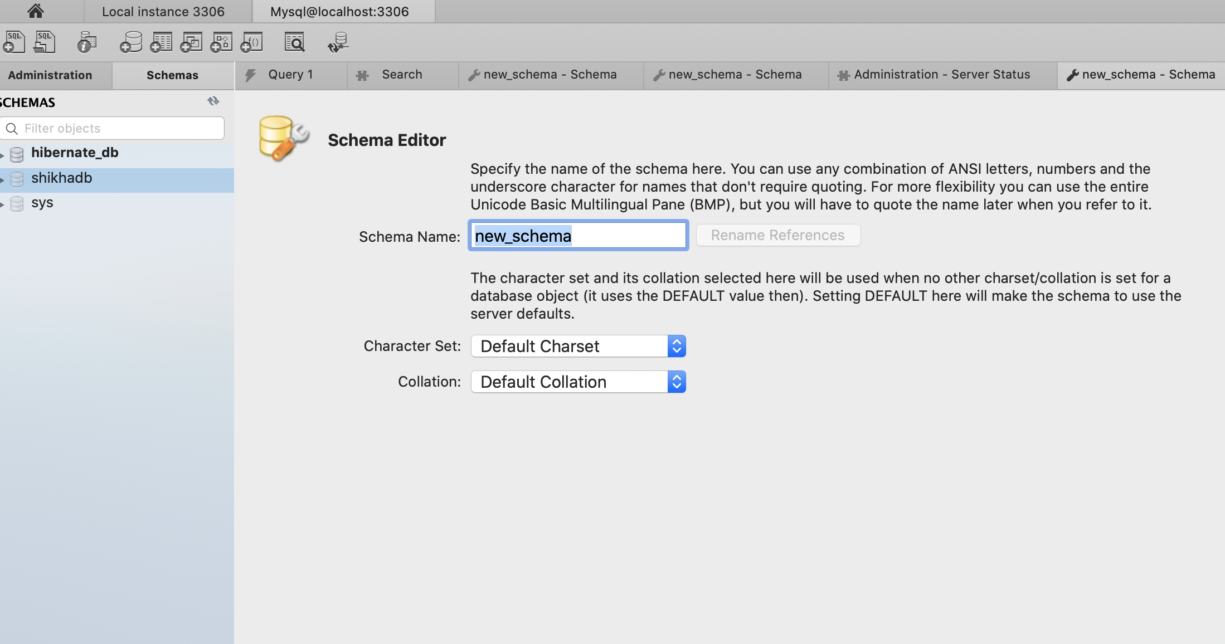

Here I created **hiberate_db** name schema...You can choose any name…

And this information write in **hibernate.cfg.xml** file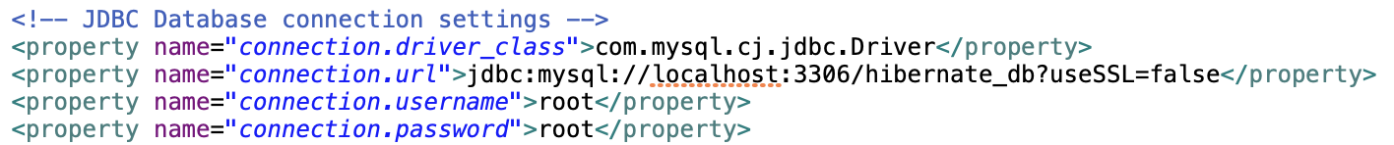

**Note- Here user put own connection URL**

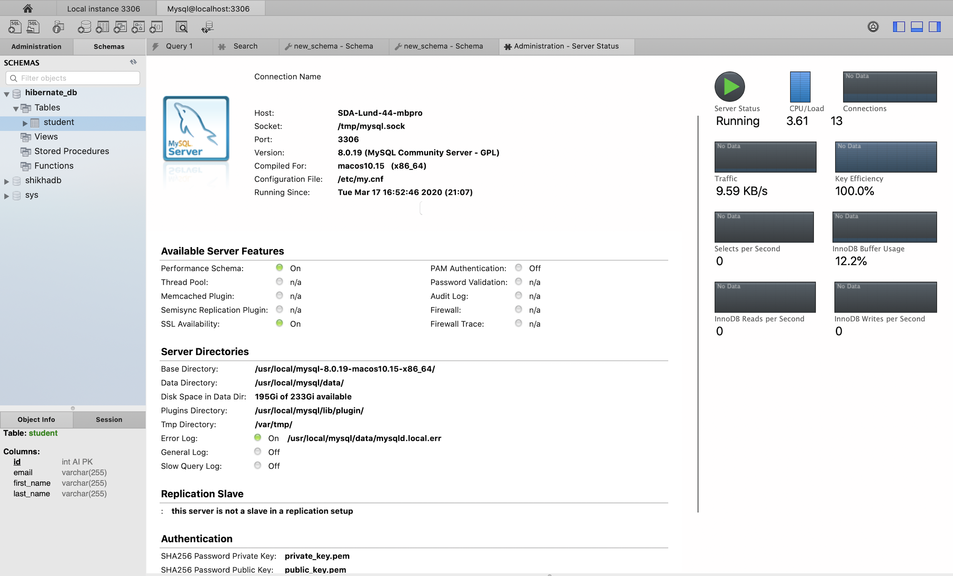

1. Mysql-connector-java-8.0.11.jar

<https://jar-download.com/artifacts/mysql/mysql-connector-java/8.0.11/source-code>

## **2 nd procedure-**

## other alternative of install HIBETRNATE,MAVEN and other supporting tool

## Open eclipse go to **help**-**Eclipse Marketplace..**

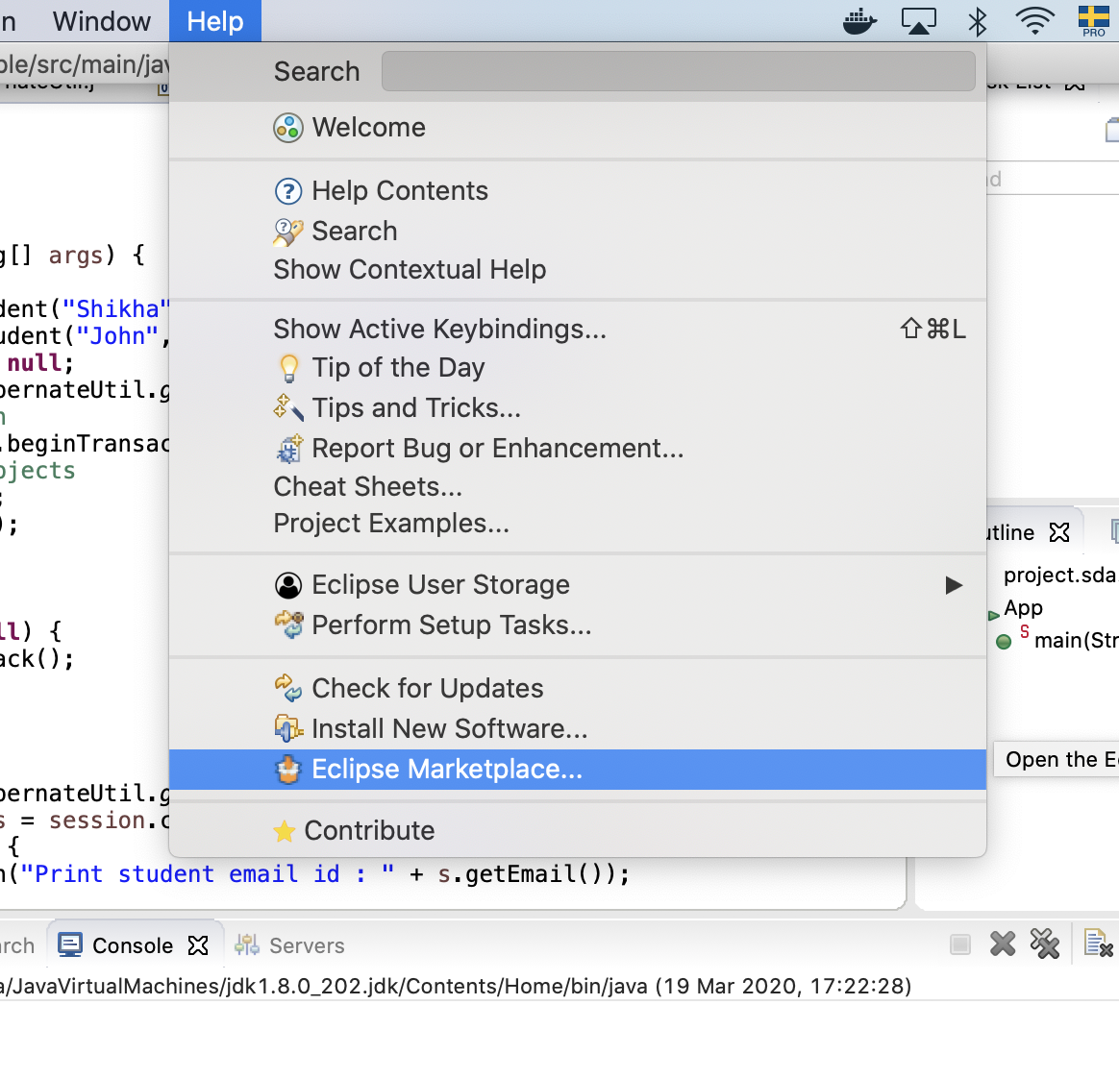

Search for **hibernate** in search bar

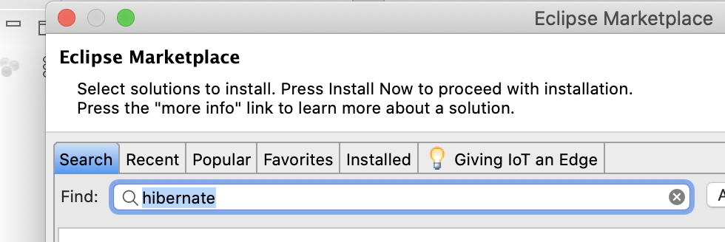

Install JBoss Tool

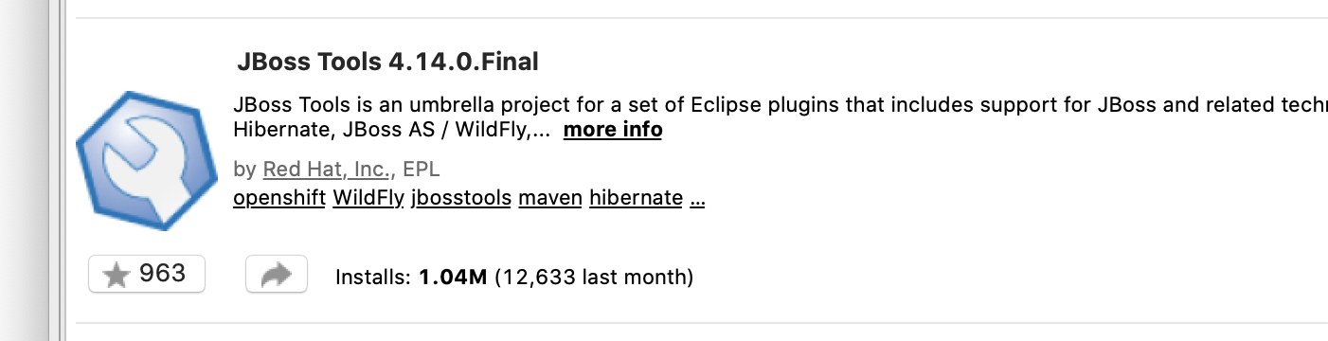

## **Development Steps**

1. Create a Simple Maven Project
2. Project Directory Structure
3. Add all jar Dependencies files
4. Add jar Dependencies to pom.xml
5. Creating the hibernate.cfg.xml
6. Creating the JPA Entity Class(Persistent class)
7. Create a Hibernate configuration file - Java Configuration
8. Create StudentDao Class
9. Create the Main class and Run an Application
10. Output

## **1. Create a Simple Maven Project**

Create the java project by **File Menu** - **New** - **other** - **search Maven -**

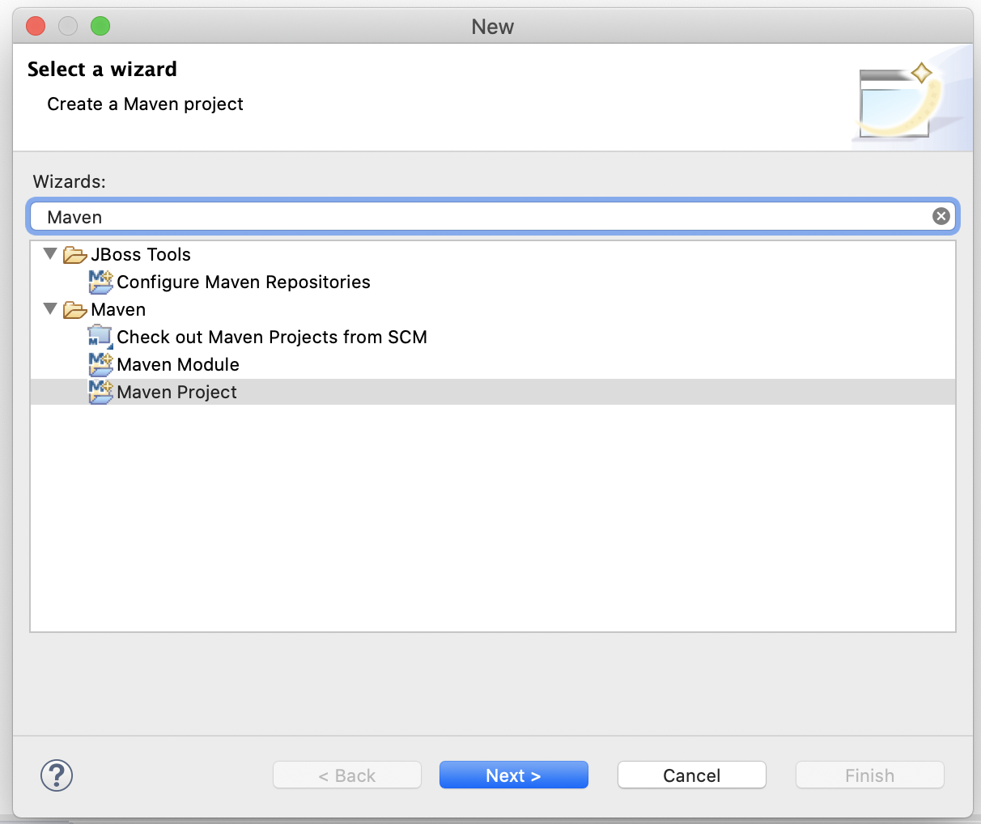

**choose Maven Project-next**.

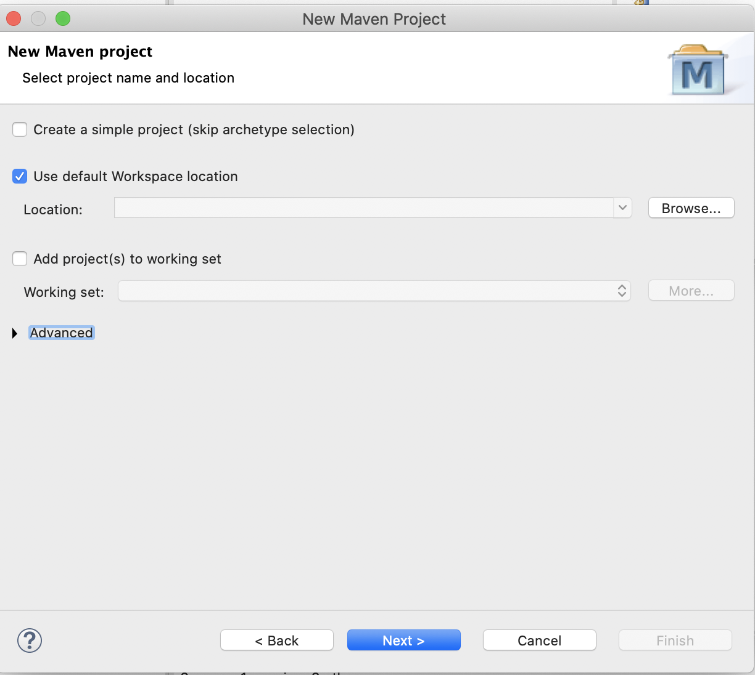

Now specify the project name e.g. Hibernate-Helloworld-Example then **next** - **finish** .

## 

## 

## 

## 

## 

## **2. Project Directory Structure**

The project directory structure for your reference -

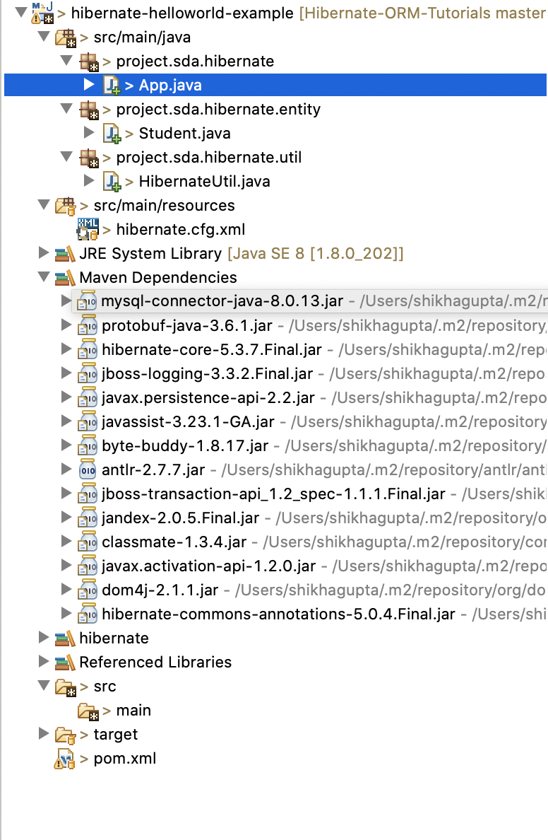

## **3. Add all jar Files and Dependencies**

Right click on **Project Name-Build Path-Choose Configure Build Path**

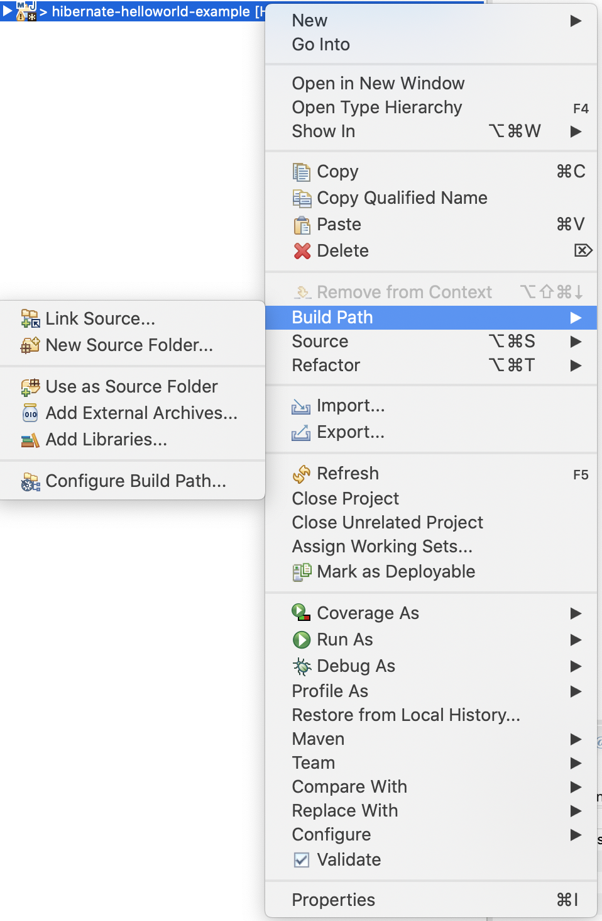

Here we can add libraries,Add External JARs….Go to the folder where you have all downloaded libraries and JARs file ..

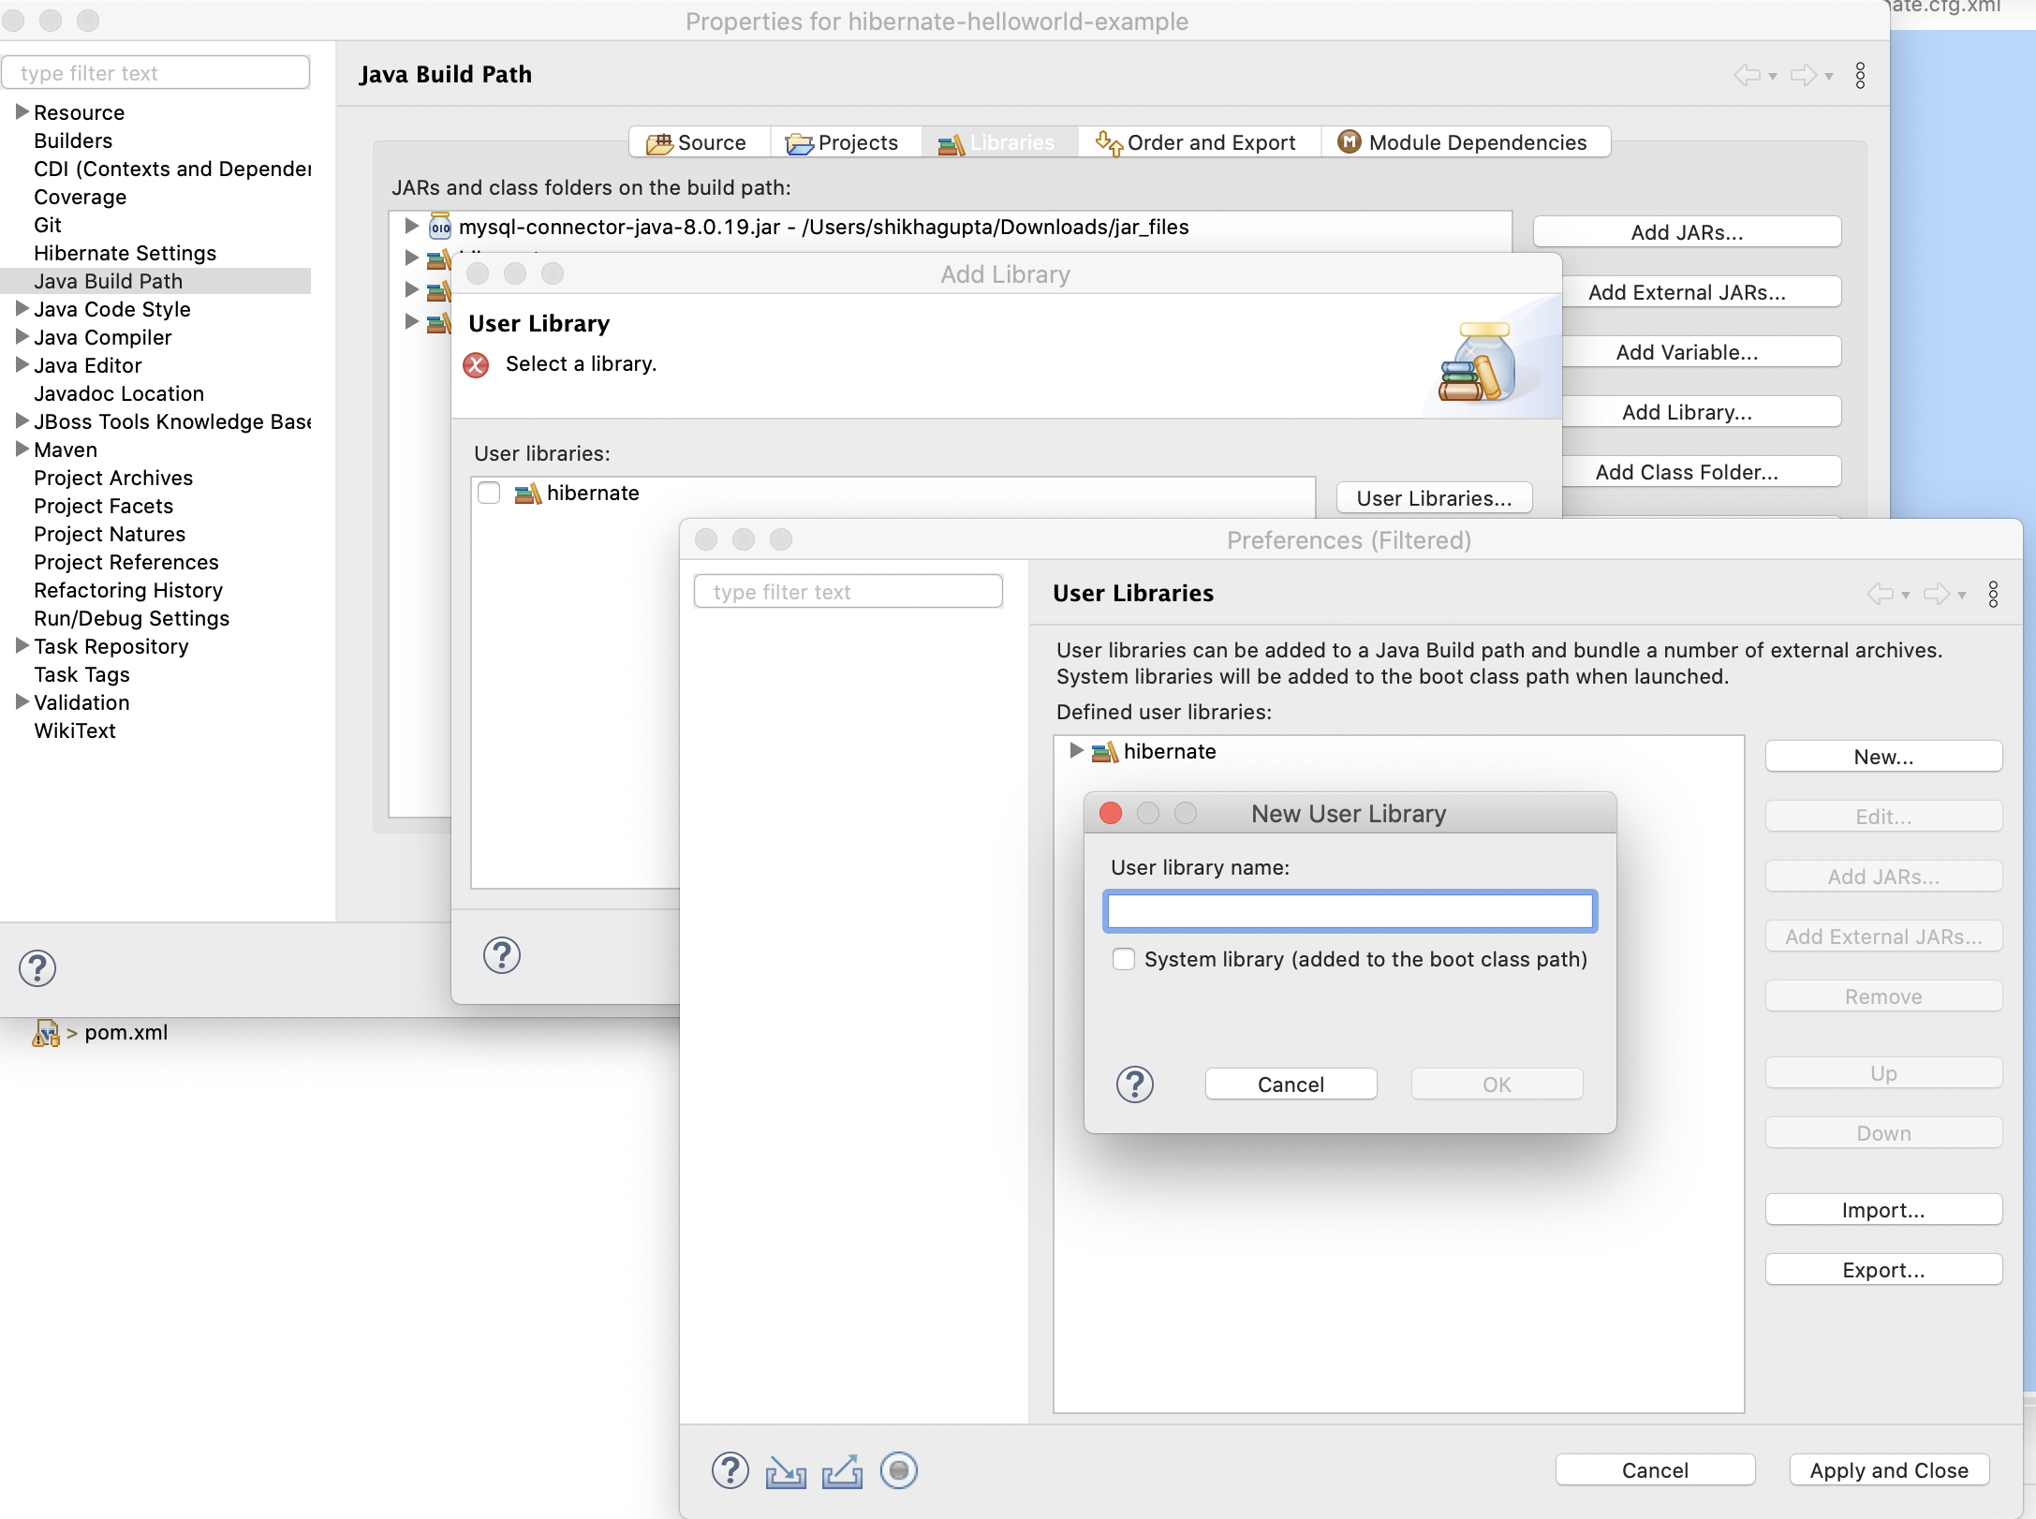

* Here I have created my own Library for Hibernate **User Library**-**Next-User Libraries -New-**giveNew User Library name**- hibernate-ok**
* for Maven **User Library**-**Next-User Libraries -New-**giveNew User Library name**- Maven Dependncies-ok**
* ForMy SQL connector**-**Go **Add External JARs-choose the path where u download the connector file.-Select it-OK**

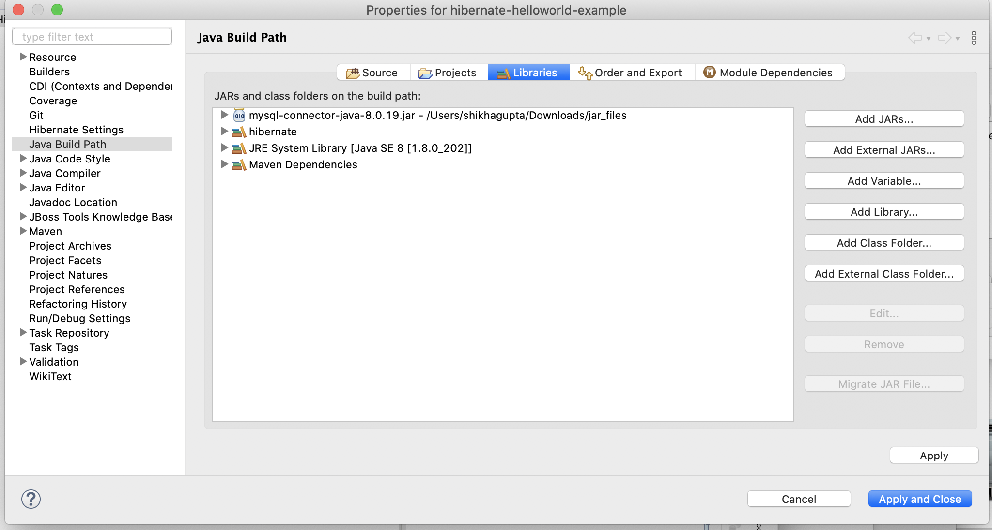

Then **Apply- Apply and Close**

## **4. Add jar Files and Dependencies to pom.xml**

<project xmlns=*"*[*http://maven.apache.*](http://maven.apache.u)*org/POM/4.0.0"*>

<modelVersion>4.0.0</modelVersion>

<artifactId>hibernate-xml-config-example</artifactId>

<version>0.0.1-SNAPSHOT</version>

<groupId>project.sda.hibernate</groupId>

<properties>

<project.build.sourceEncoding>UTF-8</project.build.sourceEncoding>

</properties>

<dependencies>

<!-- https://mvnrepository.com/artifact/mysql/mysql-connector-java -->

<dependency>

<groupId>mysql</groupId>

<artifactId>mysql-connector-java</artifactId>

<version>8.0.13</version>

</dependency>

<!-- https://mvnrepository.com/artifact/org.hibernate/hibernate-core -->

<dependency>

<groupId>org.hibernate</groupId>

<artifactId>hibernate-core</artifactId>

<version>5.3.7.Final</version>

</dependency>

</dependencies>

<build>

<sourceDirectory>src/main/java</sourceDirectory>

<plugins>

<plugin>

<artifactId>maven-compiler-plugin</artifactId>

<version>3.5.1</version>

<configuration>

<source>1.8</source>

<target>1.8</target>

</configuration>

</plugin>

</plugins>

</build>

</project>

## **5. Creating the hibernate.cfg.xml**

## 

## **<!DOCTYPE hibernate-configuration PUBLIC**

## **"-//Hibernate/Hibernate Configuration DTD 3.0//EN"**

## **"http://www.hibernate.org/dtd/hibernate-configuration-3.0.dtd">**

## **<hibernate-configuration>**

## **<session-factory>**

## **<!-- JDBC Database connection settings -->**

## **<property name=*"connection.driver_class"*>com.mysql.cj.jdbc.Driver</property>**

## **<property name=*"connection.url"*>jdbc:mysql://localhost:3306/hibernate_db?useSSL=false</property>**

## **<property name=*"connection.username"*>root</property>**

## **<property name=*"connection.password"*>root</property>**

## **<!-- JDBC connection pool settings ... using built-in test pool -->**

## **<property name=*"connection.pool_size"*>1</property>**

## **<!-- Select our SQL dialect -->**

## **<property name=*"dialect"*>org.hibernate.dialect.MySQL5Dialect</property>**

## **<!-- Echo the SQL to stdout -->**

## **<property name=*"show_sql"*>true</property>**

## **<!-- Set the current session context -->**

## **<property name=*"current_session_context_class"*>thread</property>**

## **<!-- Drop and re-create the database schema on startup -->**

## **<property name=*"hbm2ddl.auto"*>create-drop</property>**

## **<!-- dbcp connection pool configuration -->**

## **<property name=*"hibernate.dbcp.initialSize"*>5</property>**

## **<property name=*"hibernate.dbcp.maxTotal"*>20</property>**

## **<property name=*"hibernate.dbcp.maxIdle"*>10</property>**

## **<property name=*"hibernate.dbcp.minIdle"*>5</property>**

## **<property name=*"hibernate.dbcp.maxWaitMillis"*>-1</property>**

## **<mapping class=*"project.sda.hibernate.entity.Student"* />**

## **</session-factory>**

## 

## **</hibernate-configuration>**

## 

## **6.Creating the JPA Entity Class(Persistent class)**

Let's create a Student persistent class that is mapped to a **student** database table:

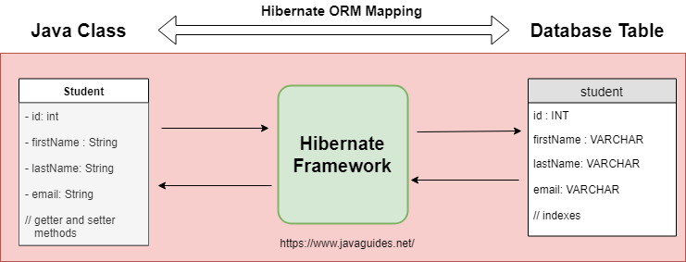

A simple Persistent class should follow some rules:

* **A no-arg constructor:** It is recommended that you have a default constructor at least package visibility so that hibernate can create the instance of the Persistent class by newInstance() method.
* **Provide an identifier property:** It is better to assign an attribute as id. This attribute behaves as a primary key in a database.
* **Declare getter and setter methods:** The Hibernate recognizes the method by getter and setter method names by default.
* **Prefer non-final class:** Hibernate uses the concept of proxies, that depends on the persistent class. The application programmer will not be able to use proxies for lazy association fetching.

Create a Student entity class under project.sda.hibernate.entity package as follows.

package project.sda.hibernate.entity;

import javax.persistence.Column;

import javax.persistence.Entity;

import javax.persistence.GeneratedValue;

import javax.persistence.GenerationType;

import javax.persistence.Id;

import javax.persistence.Table;

@Entity

@Table(name="student")

public class Student {

@Id

@GeneratedValue(strategy=GenerationType.IDENTITY)

@Column(name="id")

private int id;

@Column(name="first_name")

private String firstName;

@Column(name="last_name")

private String lastName;

@Column(name="email")

private String email;

public Student() {

}

public Student(String firstName, String lastName, String email) {

this.firstName = firstName;

this.lastName = lastName;

this.email = email;

}

public int getId() {

return id;

}

public void setId(int id) {

this.id = id;

}

public String getFirstName() {

return firstName;

}

public void setFirstName(String firstName) {

this.firstName = firstName;

}

public String getLastName() {

return lastName;

}

public void setLastName(String lastName) {

this.lastName = lastName;

}

public String getEmail() {

return email;

}

public void setEmail(String email) {

this.email = email;

}

@Override

public String toString() {

return "Student [id=" + id + ", firstName=" + firstName + ", lastName=" + lastName + ", email=" + email + "]";

}

}

## **7. Create a Hibernate configuration file - Java Configuration**

The **HibernateUtil** Java configuration file contains information about the database and mapping file.

Let's create a **HibernateUtil** file and write the following code in it.

package project.sda.hibernate.util;

import org.hibernate.SessionFactory;

import org.hibernate.boot.Metadata;

import org.hibernate.boot.MetadataSources;

import org.hibernate.boot.registry.StandardServiceRegistry;

import org.hibernate.boot.registry.StandardServiceRegistryBuilder;

public class HibernateUtil {

private static StandardServiceRegistry registry;

private static SessionFactory sessionFactory;

public static SessionFactory getSessionFactory() {

if (sessionFactory == null) {

try {

// Create registry

registry = new StandardServiceRegistryBuilder().configure().build();

// Create MetadataSources

MetadataSources sources = new MetadataSources(registry);

// Create Metadata

Metadata metadata = sources.getMetadataBuilder().build();

// Create SessionFactory

sessionFactory = metadata.getSessionFactoryBuilder().build();

} catch (Exception e) {

e.printStackTrace();

if (registry != null) {

StandardServiceRegistryBuilder.destroy(registry);

}

}

}

return sessionFactory;

}

public static void shutdown() {

if (registry != null) {

StandardServiceRegistryBuilder.destroy(registry);

}

}

}

## **8.Create StudentDao Class**

Let's create a separate **StudentDao** class to separate out hibernate related stuff.

package project.sda.hibernate.dao;

import java.util.List;

import org.hibernate.Session;

import org.hibernate.Transaction;

import project.sda.hibernate.entity.Student;

import project.sda.hibernate.util.HibernateUtil;

public class StudentDao {

public void saveStudent(Student student) {

Transaction transaction = null;

try (Session session = HibernateUtil.getSessionFactory().openSession()) {

// start a transaction

transaction = session.beginTransaction();

// save the student object

session.save(student);

// commit transaction

transaction.commit();

} catch (Exception e) {

if (transaction != null) {

transaction.rollback();

}

e.printStackTrace();

}

}

public List < Student > getStudents() {

try (Session session = HibernateUtil.getSessionFactory().openSession()) {

return session.createQuery("from Student", Student.class).list();

}

}

}

## **9. Create the main App class and Run an Application**

Let's test Hibernate application to connect MySQL database.

package project.sda.hibernate;

import java.util.List;

import org.hibernate.Session;

import org.hibernate.Transaction;

import project.sda.hibernate.entity.Student;

import project.sda.hibernate.util.HibernateUtil;

public class App {

public static void main(String[] args) {

Student student = new Student("Shikha", "Gupta", "shiknema@gmail.com");

Student student1 = new Student("John", "Cena", "john@gmail.com");

Transaction transaction = null;

try (Session session = HibernateUtil.getSessionFactory().openSession()) {

// start a transaction

transaction = session.beginTransaction();

// save the student objects

session.save(student);

session.save(student1);

// commit transaction

transaction.commit();

} catch (Exception e) {

if (transaction != null) {

transaction.rollback();

}

e.printStackTrace();

}

try (Session session = HibernateUtil.getSessionFactory().openSession()) {

List<Student> students = session.createQuery("from Student", Student.class).list();

students.forEach(s -> {

System.out.println("Print student email id : " + s.getEmail());

});

} catch (Exception e) {

if (transaction != null) {

transaction.rollback();

}

e.printStackTrace();

}

}

}

## **10.Output**

